Wednesday 15th April 2020

Mr and mrs dicarlo

Mr and mrs dicarlo live in an old italian neiborhood(vecindario) in NY city they speak a little English but usually they speak Italian they read the Italian newspaper they listen the Italian radio programs, they shot at the Italian grocery store around the corner from their apartament building and every day they visit their friend and neigbohoors(vecinos) and talk about life back in the old country, mr and mrs dicarlo are upset about theyr son joe, he lives in small suburb out side the city he speaks a little Italian but usually he speak English he reads American newspapers, he listen two American radio programs, he shops at big suburban supermarkets and shoping malls and when he visits his friends and neighbors he always speaks English.

Busy people

Jeff is a very athletic person he does a different kind of exercise or sport every day in Monday he jugs(?) on thuesday he plays tennis, on Wednesday he play joga, on Thursday he swims, on Friday he goes to a hell club(?)on Saturday he plays baskqueball, and on Sunday he rides his bike, july is a very busy student she does a different activity every day on Monday she sings in the quire(?), on thuesday she plays in the orquesta on Wednesday she writes for the school newspaper on Thursday she plays volleyball, on Friday she babysits for her neighbors on Saturday she works at the mall and on Sunday she visits her grandparents

Age

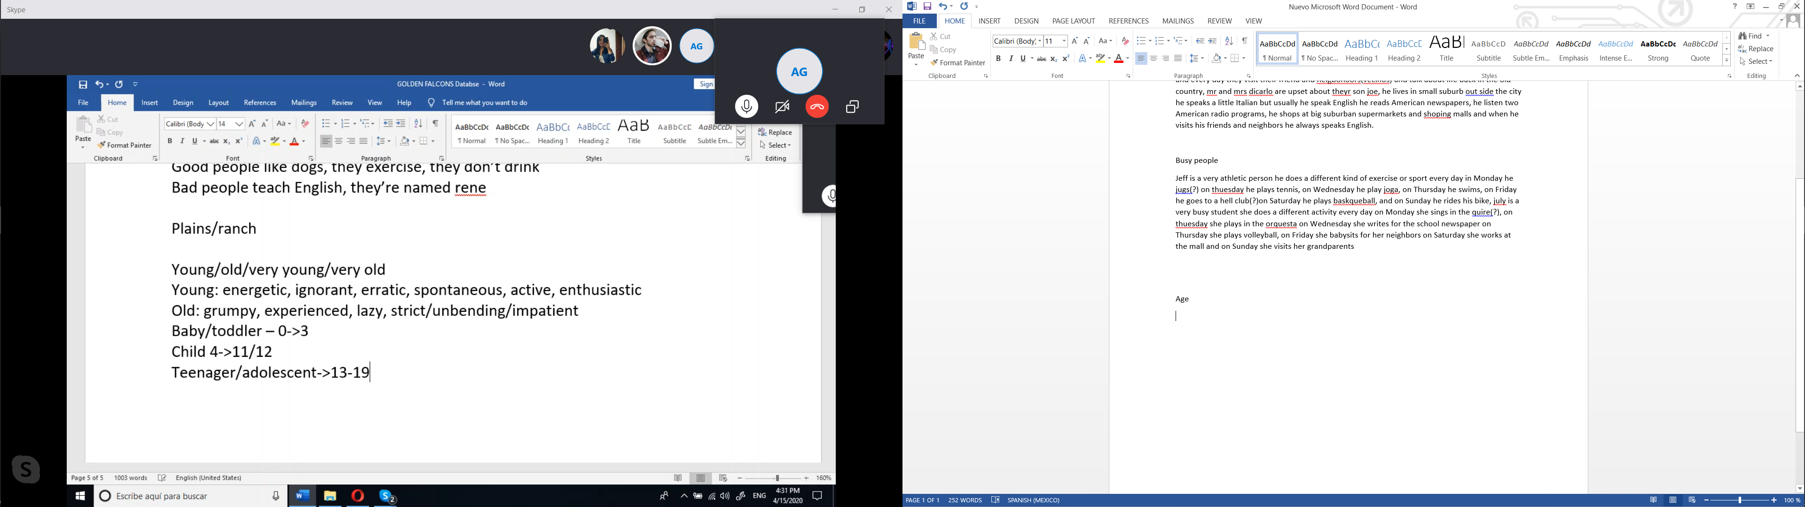

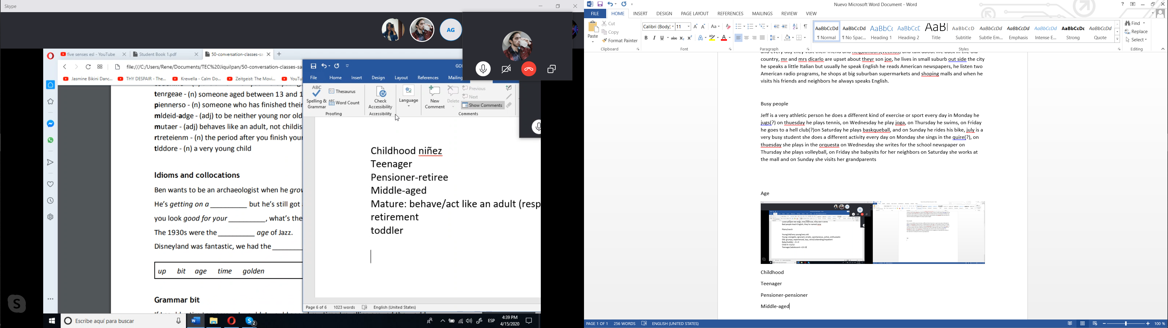

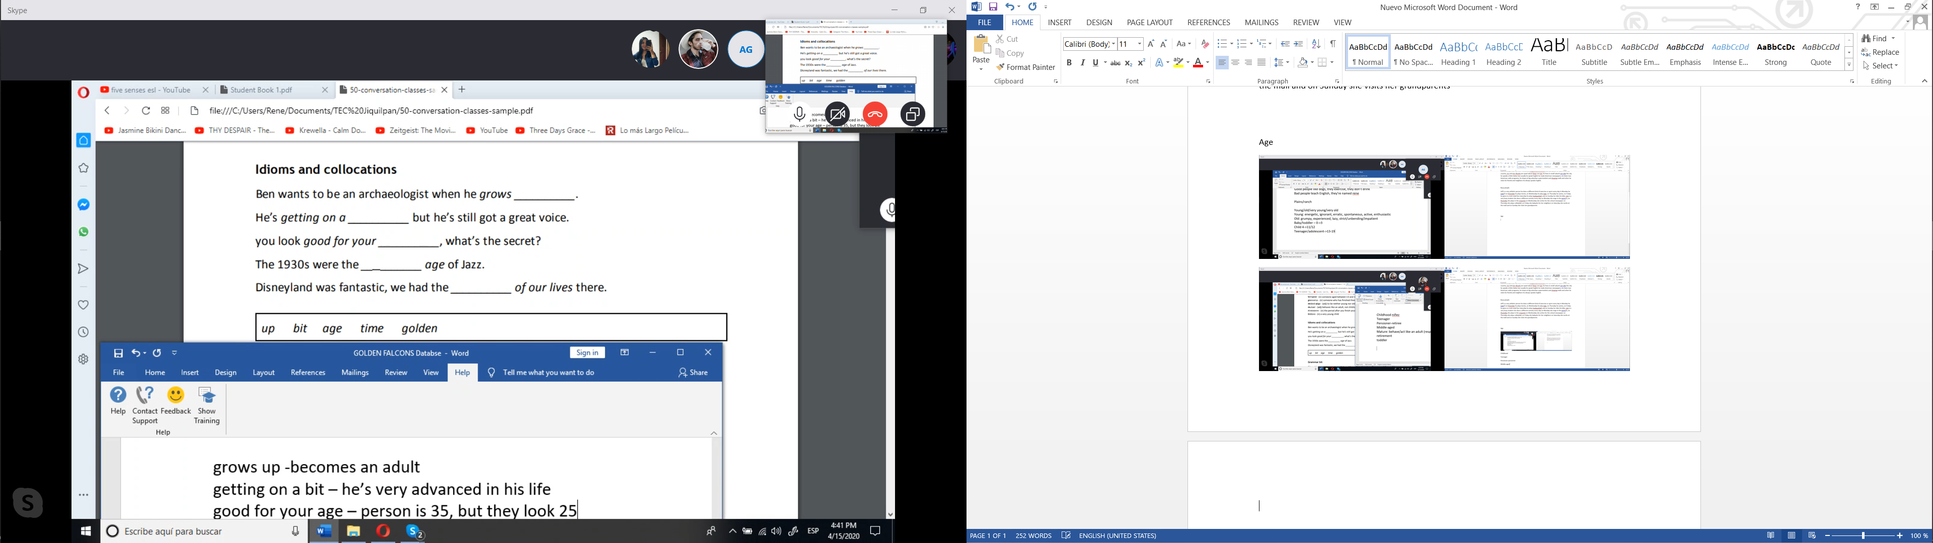

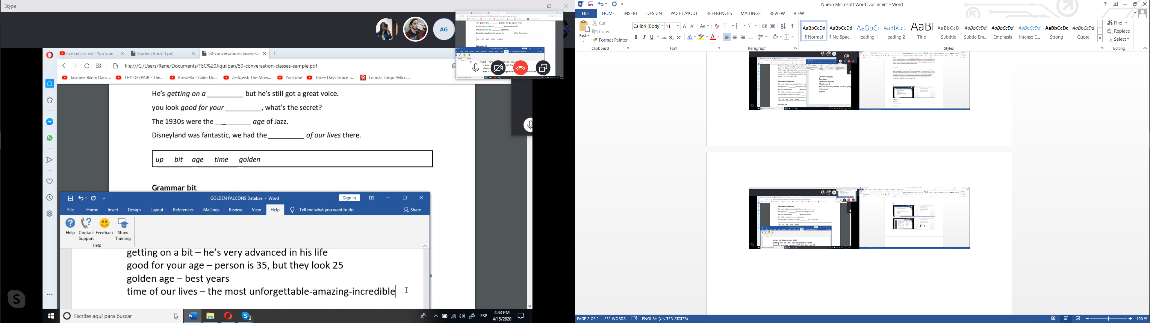

Hypothetical

If I could…I would…